**Nama : Raihan Romzi R**

**Batch : 9**

1. **Show an array that is a combination of these 2 arraysGraphical user interface, text

   Description automatically generated**
2. **Show first name of all usersText

   Description automatically generated**
3. **Show user age under 30 and gender is femaleText

   Description automatically generated**
4. **Show user who have first name that starts with "j" (case-insensitive)**

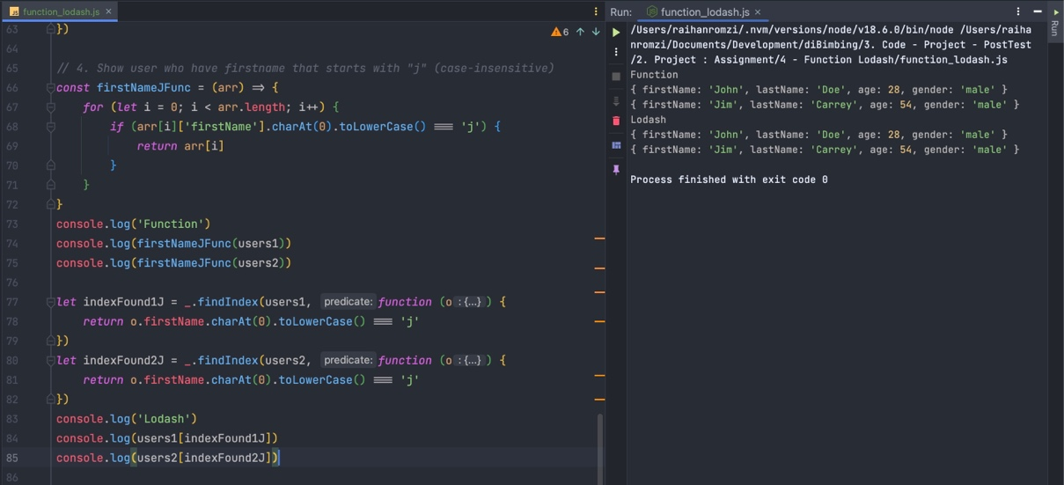

1. **Show user who have last name that contains letter "a" (case-insensitive)Text

   Description automatically generated**